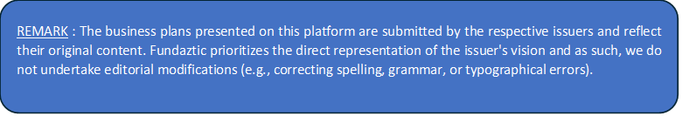

BACKGROUND OF BUSINESS

A. Who are we

B. What do we do

C. When did we start our business operations

D. Where we are operating our business in

E. How much have we invested into the business to-date

F. No. of Outlets/Branches we have now (if any)

G. Our Financial Summary
Year | Turnover | Total Expenses | Profit / (Losses)
2025 ^
2026 up to date ^
*Remark/Clarification – ( if any )
^ the above year for illustration purpose only, please declare previous and current year turnover.

H. Experience of our Key Management Team

I. Staffing – Staff Strength

J. How we intend to use and repay the funds

K. Other supporting information about our company

