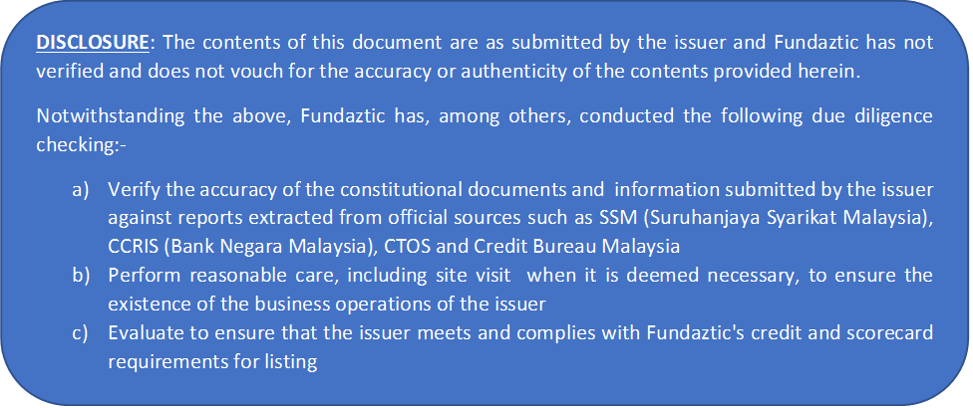

BACKGROUND OF BUSINESS

A. Who are we

B. What do we do

C. When did we start our business operations

D. Where we are operating our business in

E. How much have we invested into the business to-date

F. No. of Outlets/Branches we have now (if any)

G. Our Annual Sales Turnover

H. Experience of our Key Management Team

I. Staffing – Staff Strength

J. How we intend to use and repay the funds

K. Other supporting information about our company

